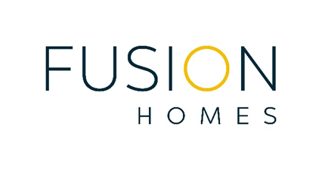

Love the Journey
As a 2022 Kincentric Best Employer, we approach the employee experience the same way we approach the customer experience. Buying a new home can be rewarding, challenging, and, ultimately, life changing. A new home is not just one of the largest purchases made in a lifetime; it becomes a defining part of the buyer. The employee experience is no different and our deep devotion to our people propels everything we do.
For us to deliver an unparalleled customer experience and drive the business with immense growth ahead, we require a unique mix of unbelievably rare people. We care first and foremost about talent and the unrelenting drive to defy the expectations set out ahead of us. To rise to the occasion, we consistently over-deliver, and live each day with a clear purpose of doing better than we did the day before.
Join the Fusion Team
Fusion Homes is searching for an exceptionally talented Project Coordinator to join our growing team and help us deliver on our customer promise. The Project Coordinator will be highly impactful with an unlimited growth trajectory, supporting the Mixed-Use Development (High-rise, Commercial, Stacked Townhomes) Project Management team throughout the management and monitoring of the key stages of projects at Fusion Homes.
What you’ll be doing:
- Support and be part of the Mixed-Use Development (High-rise, Commercial, Stacked Townhomes) Project Management team throughout the management and monitoring of the 11 key stages of projects.
- Assist with project scheduling creation, monitoring and updates including input for categories/timelines/construction process.
- Quarterback communication with third party Construction Managers and other consultants and trades to resolve issues with scheduling/product sourcing/design issues, etc.
- Code invoices, logging change order and invoice trackers and verifying amounts against progress on site.
- Assist in tendering and procurement of projects to consultants and trades.
- Perform condo performance audit inspections, document major warrantable deficiencies and follow up with the site staff to confirm deficiency corrections and inspections.
- Review existing warranties, guarantees, and service contracts for each common element component.
- Assist and provide support on various areas including the following:
  - Coordinate siting analysis
  - Due diligence activities and feasibility studies
  - Zoning applications
  - Minor variances
  - Proformas and budgets
  - Draft Plan of Subdivision
  - Subdivision Registration

What you bring to the table:
- 3+ years in high-rise project coordination role.
- Concise and detailed oriented with a strong willingness to lead and collaborate.
- Post-secondary education in Architecture, Engineering, Project Management, or related field.
- Must be proficient Microsoft Office suite and MS project; knowledge of AutoCAD considered an asset.
- Ability to effectively read Floor Plans and Working Drawings.
- Expert Written and Verbal Communication skills.
Why you should join Fusion:
- Performance-based bonus system
- Industry-leading benefits program
- Hybrid work environment
- 4 weeks of vacation after just 1 year
- Incredible opportunities for growth
Learn more about joining the Fusion team at https://fusionhomes.com/careers/
Fusion Homes is an equal opportunity employer that champions diversity and inclusion in the workplace. We are committed to providing barrier-free employment for all individuals, commencing with the hiring process. Should you require accommodations due to a disability at any point during your journey with Fusion Homes, please contact us via email at accessibility@fusionhomes.com. To learn more, please review our Accessibility Policy.
Applicants are to contact:
Brittani Stevenson
Manager, Executive Talent Acquisition
519-826-6700, ext. 290 | 226-343-5705
bstevenson@fusionhomes.com

